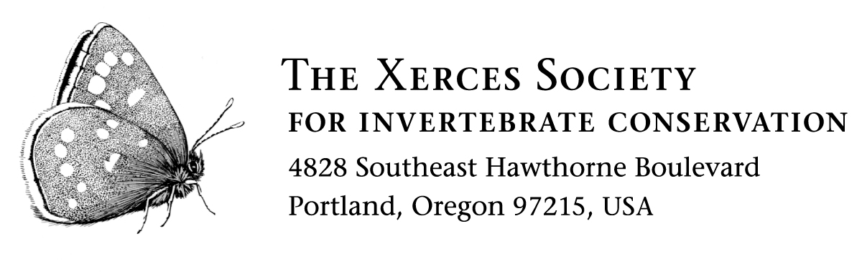
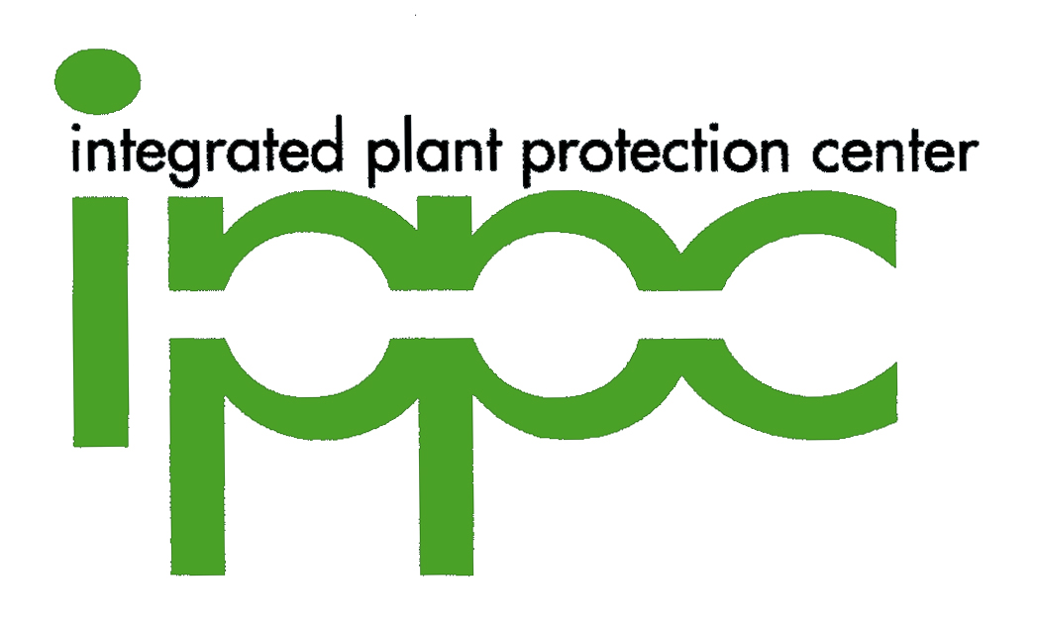

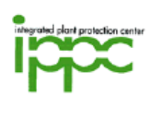
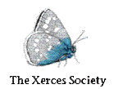
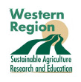

SAVE THE DATE!
WORKSHOP: Habitat and Conservation Practices for
Beneficial Insects on Farms: Predators, Parasites and Pollinators

The Dalles: April 21, 2008
Klamath Falls: April 28, 2008
Willamette Valley (Lebanon): May 13, 2008
Medford: June 3, 2008
Most workshops will run from about 10:00 to 3:00 to allow time for travel.

These free half-day workshops for agricultural professionals (NRCS, SWCD, Cooperative Extension, crop consultants and others) and growers will include presentations on enhancing habitat for beneficial insects and a field trip to nearby farms to see examples of habitat on the ground.

In each workshop you will learn about:
● Why pollinator, parasitic and predatory insects are important for our food system
● The importance of habitat nearby crops for these insects
● Practical steps you can take to improve beneficial insect populations on your land

Beneficial insects live wild in agricultural landscapes and can provide valuable services to farms. Predatory and parasitic insects are critically important for helping to keep pest insects in check, and native bees can be significant pollinators of crops. However, to meet their potential for doing work on farms, these beneficial insects require natural habitat features that are often lacking in farm landscapes. Providing or enhancing existing habitat for these animals – and the important services they provide – helps farm production and improves environmental quality. This workshop will address how conservation buffers and other on-farm habitat can be enhanced to increase populations of these beneficial insects. This workshop will be followed up by a second workshop (date TBA) which will feature a full-day technical training on farm planning for beneficial insect habitat.

The workshop will be presented by Matthew Shepherd, a Senior Conservation Associate with The Xerces Society for Invertebrate Conservation, and Paul Jepson, Professor of Environmental & Molecular Toxicology and Director of the Integrated Plant Protection Center (IPPC) at Oregon State University.

We will mail out electronic invitations with workshop details in the coming days. For more information on beneficial insects, visit: The Xerces Society for Invertebrate Conservation at www.xerces.org and the Integrated Plant Protection Center at http://www.ipmnet.org.

